Title I Program  What is Title I?  Title I, Part A of the Elementary and Secondary Education Act (ESEA) provides financial assistance to states and school districts to meet the needs of educationally at-risk students. The goal of Title I is to provide extra instructional services and activities which support students identified as failing or most at risk of failing the state’s challenging performance standards in mathematics, reading, and writing. Our Program is targeted assist which helps eligible children by placing them with Title I staff who are specially trained. This service is completely funded by Title I.  What will Title I do for my child?  The Title I program will provide your student with extra educational assistance beyond the regular classroom.  What do Title I programs offer?  Title I programs offer:  - Smaller classes or special instructional spaces.  - Additional teachers  - Opportunities for professional development for school staff  - Extra time for teaching Title I students the skills they need.  - A variety of supplementary teaching methods  - An individualized program for students  - Additional teaching materials which supplement a student’s regular instruction |  | How Can I Be Involved?  - Joining the school PTO and regularly attending meetings  - Volunteering at school  - Attending parent/teacher conferences & communicating with your child’s teacher  - Returning all papers, including parent surveys  - Keeping your child’s teacher informed about events in your child’s life which may affect his or her performance  - Ensuring your child’s prompt arrival to school  - Asking each day “How was your day?”  - Reading to/with your child on a daily basis  - Becoming an advocate for education |  | School Parent Compact  The compact is an agreement between the parents, student and school to help ensure each child’s academic success. It is a shared commitment that all involved are going to work together to improve learning. This compact is required by the Federal Title I guidelines.  Eligibility Requirements  A variety of factors are used to determine student eligibility, including but not limited to: standardized tests, classroom-based assessments and performance, as well as teacher recommendations.  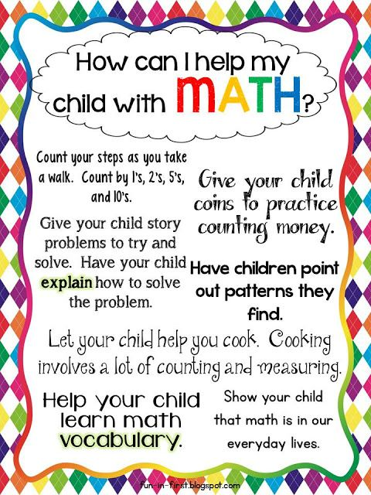
Parent & Family Engagement

We support parent and family engagement in our schools and in virtual learning. We promote efforts to build school and family partnerships and to build parent capacity for increasing student achievement.

Decision Making – You can make important decisions about your child’s school by participating in meetings such as the Title I Annual Meeting and Parent Advisory Meetings.

Compact – Each school has a School Parent compact that outlines how parents and school personnel will be responsible for supporting students.

Participation – Parent activities and trainings are developed around responses to the Title I surveys as well as needs identified throughout the school year.

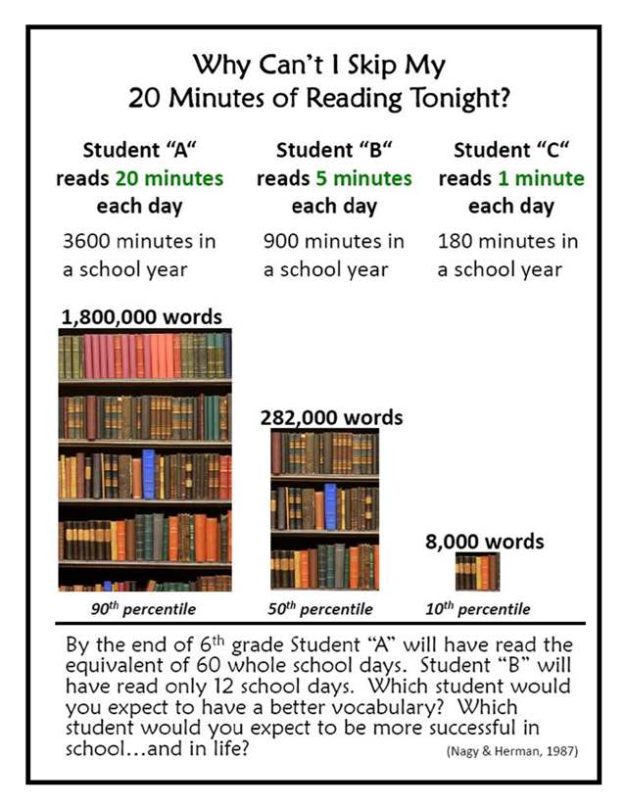  How do I get my 20  minutes of reading a day?  - Read during snack time  - Keep a few books in the car  - Make a set time to read aloud to your child – even if it’s just for 5 minutes.  - Read EVERYTHING – signs, food boxes, magazines, etc..  - Keep books by their beds  - Have a set time for your child to read quietly to themselves  - Play Reading games – hangman, Brain Quest, etc.  - Listen to stories online. Try Storytime Online |  | State Street Elementary  355 East State Street  Larksville, PA 18704  (570)779-5381  Fax (570)779-2023  Principal  Mr. Tim Needle  Assistant Principal  Mr. William Wright  Reading Specialists:  Ms. Lori Bantel  Mrs. Michelle Brady  Mrs. Brenda Glynn  Mrs. Lindsey Keating  Mrs. Jennifer Martinak  Mr. George Mizzer  Mr. Bill Stone  Mrs. Amy Stitzer-Yerke  Math Specialists:  Ms. Katy Meade  Mr. Frank O’Boyle  Mrs. Lara Romanowski  Mrs. Amy Rothschild  Mr. Jaime Stinson |  | Wyoming Valley West  School District  Title 1  State Street Elementary    Mr. David Tosh  Superintendent of Schools  Mrs. Debbie Troy  Title I Coordinator  (570) 288-6551 ext. 10402  Ms. Kelly Thomas  Title I Secretary  (570) 288-6551 ext. 10400

